1. Overview
You now have a basic vocabulary for talking about game design: goals, rules, challenge, feedback, core loops, player experience, and game feel. In this lab, you'll learn how to place your game or other games in a broader context of game genres.
You'll learn to do the following:
- Understand why genres matter and what players expect from them
- Learn about common genres, with typical gameplay and example games (including Unity titles)
This lab will help you make informed choices about genre in your GDD.
Mark step complete
2. Genres and player verbs
Genres are a useful shorthand. When players hear "puzzle game" or "action RPG," they can instantly picture what they'll be doing and what kind of challenge to expect.
One common way designers think about genres is through player verbs: simple action words like run, jump, shoot, build, talk, solve, etc. This isn't the only framework for thinking about genres, but verbs provide a concrete, widely understood shorthand for what players actually do in the game most of the time.
For example, we might say that "common actions (verbs) in this genre are…"
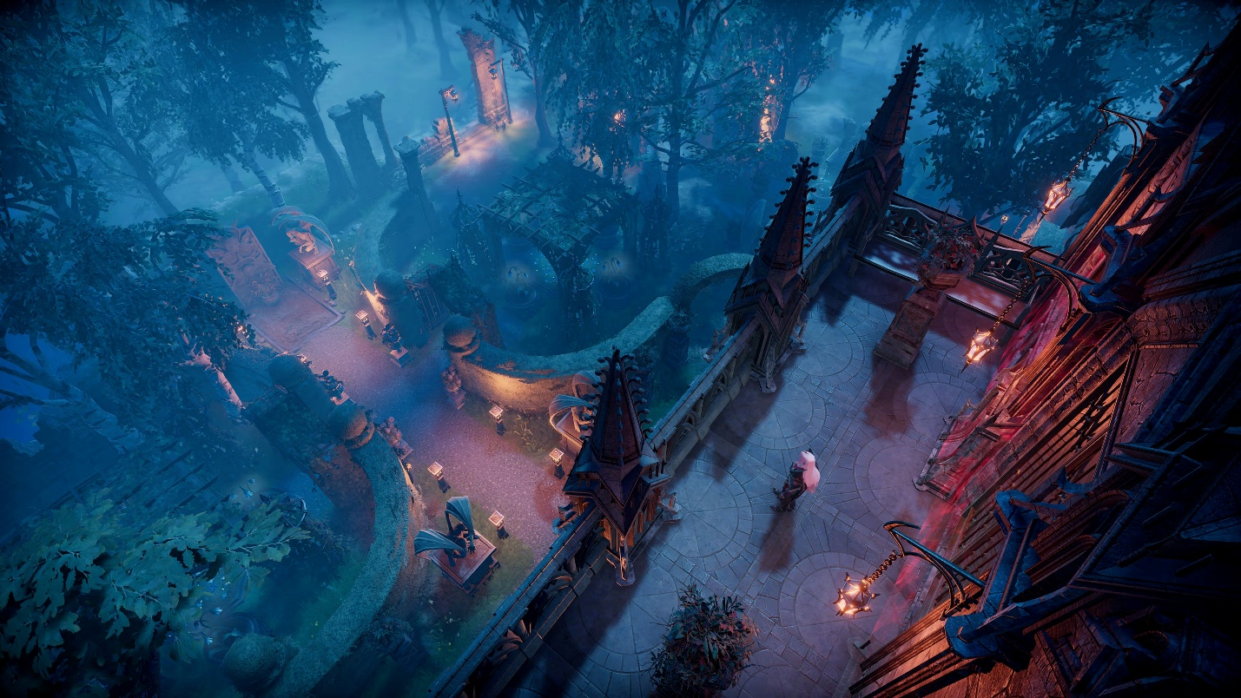
Screenshot from case study on V Rising
3. Common genres
Below is a list of major game genres. For each genre, you'll find the following:
- Typical gameplay in one sentence
- Common actions / verbs
- Example games, including ones made with Unity
Note: These descriptions are generalizations. Individual games within a genre can feel dramatically different based on their specific mechanics, pacing, and style. Also, genre boundaries are rarely clean or fixed. Most modern games are hybrids that blend elements from multiple genres. A game can be a "roguelike action platformer with RPG progression" or a "puzzle game with narrative adventure elements." Genres are descriptive tools, not rigid boxes.
Action / Platformer
- Typical gameplay: Navigate levels in real time, avoid hazards, and defeat enemies using responsive movement and attacks.
- Common actions: Run, jump, dodge, attack.
- Examples: Celeste, Ori and the Blind Forest (made with Unity)
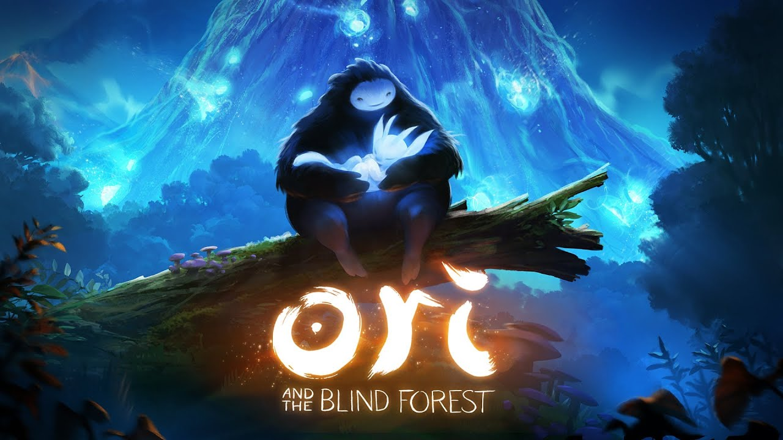
Puzzle
- Typical gameplay: Solve challenges by understanding the rules of a system.
- Common actions: Think, plan, match, rotate, route, optimize.
- Examples: Tetris, Monument Valley
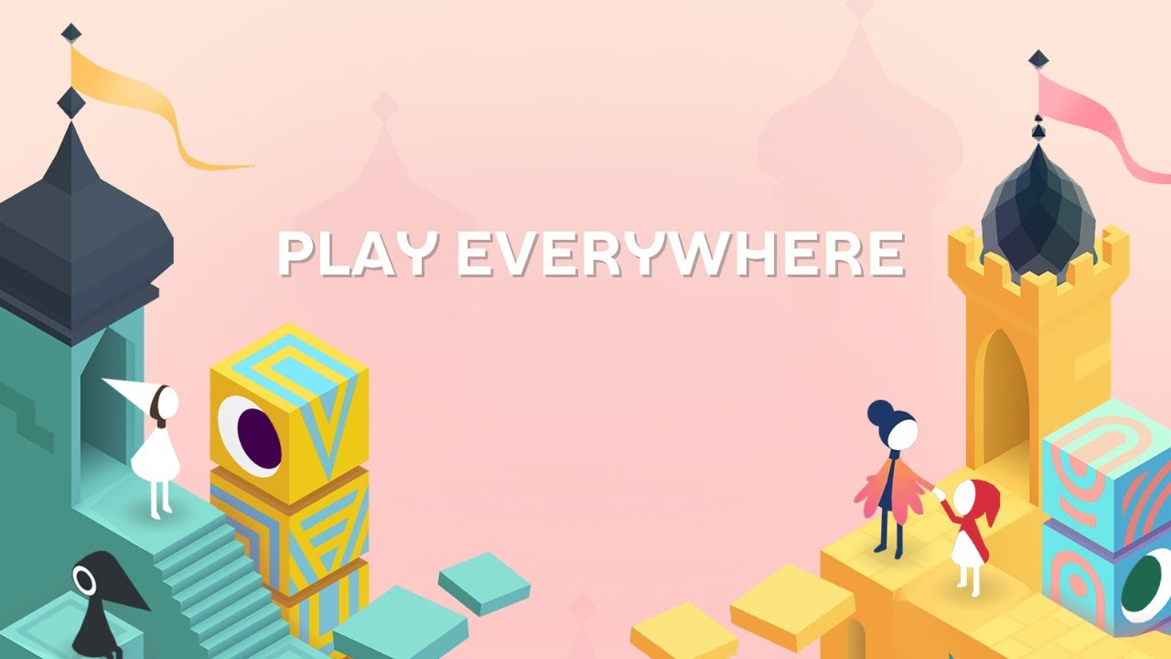
Shooter / First person shooter (FPS)
- Typical gameplay: Use ranged weapons to defeat enemies while staying alive in real time.
- Common actions: Aim, shoot, evade, reload, take cover or reposition.
- Examples: Overwatch, Call of Duty: Mobile (made with Unity)
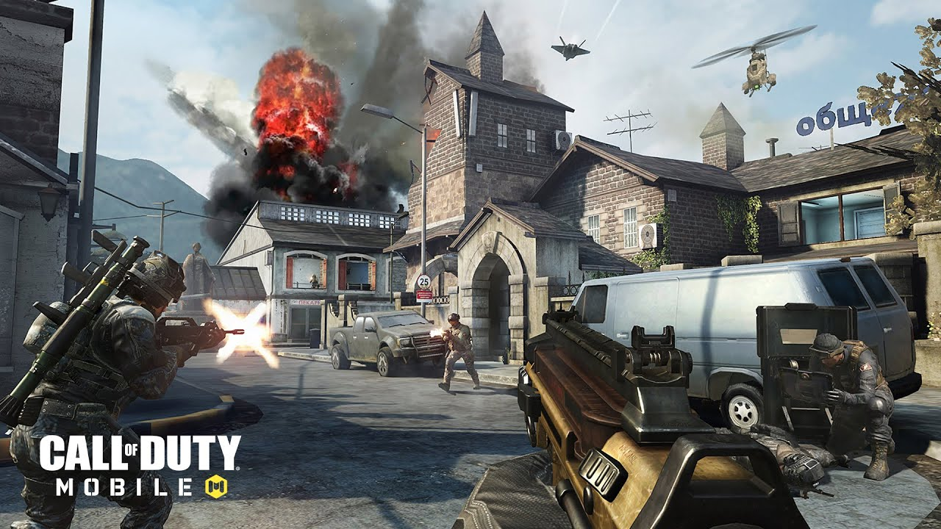
Role-playing game (RPG)
- Typical gameplay: Control one or more characters, grow their abilities, and make choices as you progress through a world or story.
- Common actions: Explore, fight, level up, equip, specialize, talk to NPCs.
- Examples: Skyrim, Genshin Impact (made with Unity)
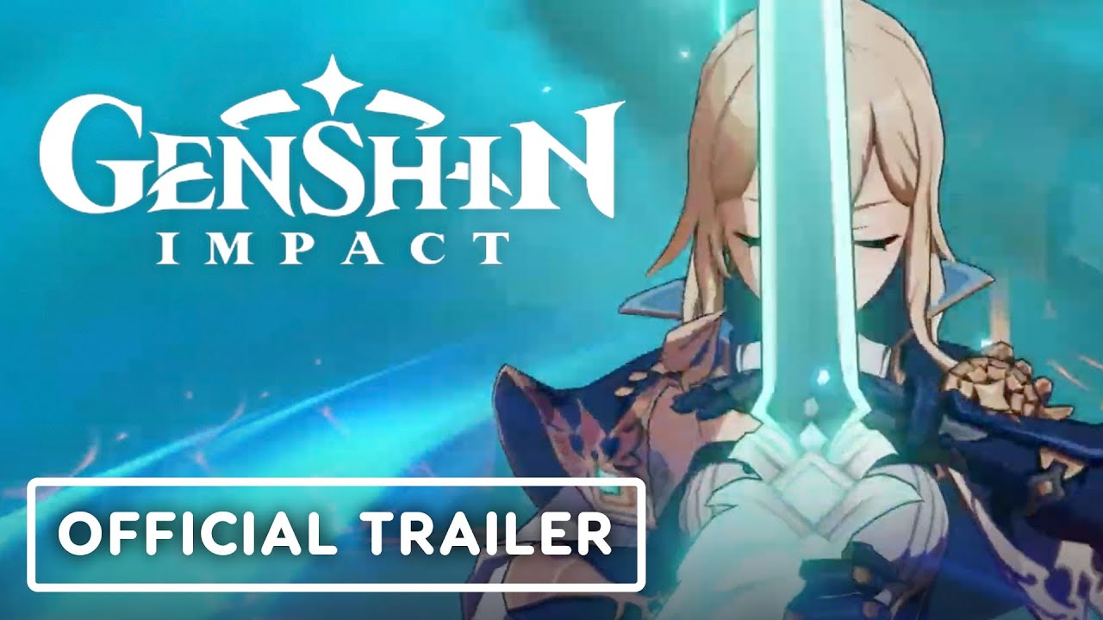
Real-time strategy (RTS) / Tactics
- Typical gameplay: Make medium- or long-term plans to outsmart opponents or manage systems, often from a top-down view.
- Common actions: Plan, manage, position, command, allocate resources.
- Examples: StarCraft, RimWorld (made with Unity)
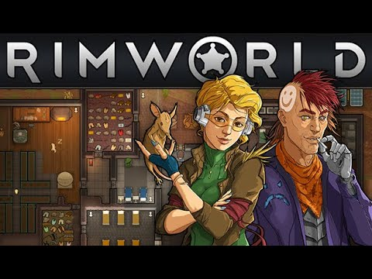
Simulation / Sandbox
- Typical gameplay: Experiment with systems, build or manage things, and create your own goals in an open-ended environment.
- Common actions: Build, place, tweak, manage, experiment, customize.
- Examples: The Sims, Minecraft, Cities: Skylines (made with Unity)
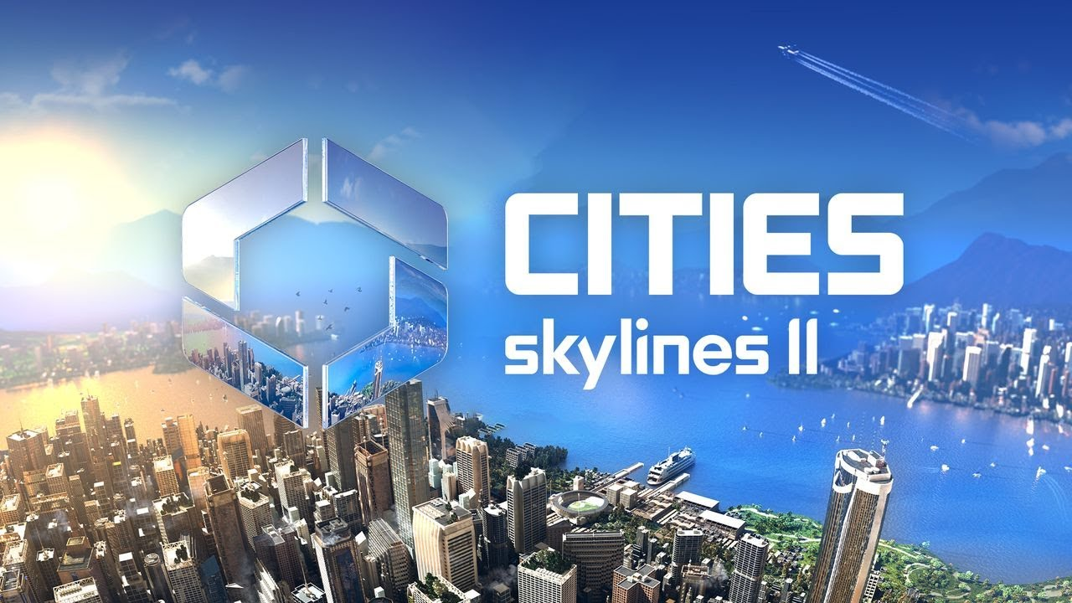
Fighting
- Typical gameplay: One-on-one or small group matches with an emphasis on timing and move sets.
- Common actions: Time attacks, combo, block, dodge, counter.
- Examples: Street Fighter, Fantasy Strike (made with Unity)
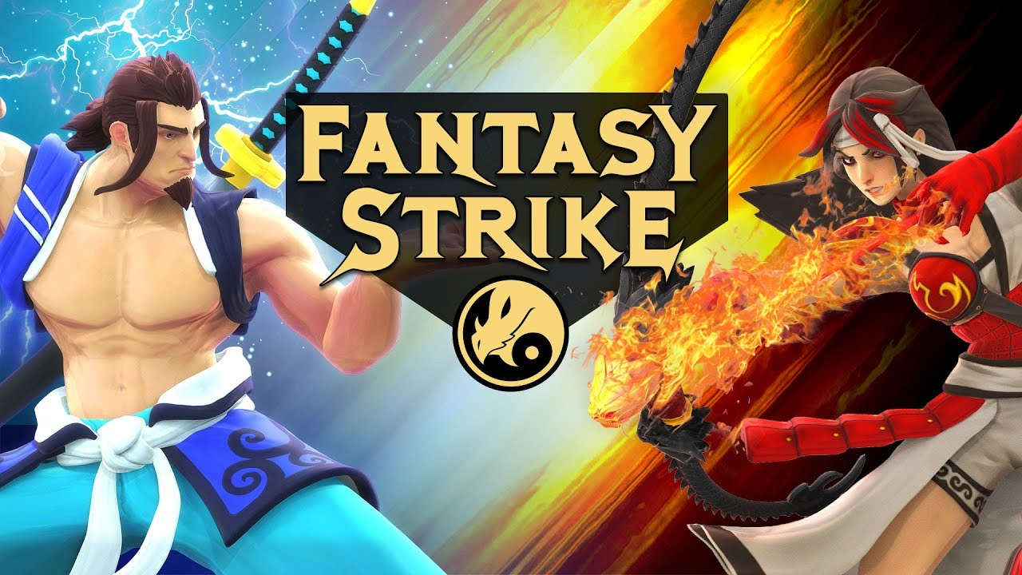
Racing / Sports
- Typical gameplay: Compete to finish fastest or score more points within a familiar sport or race format.
- Common actions: Steer, accelerate, brake, time actions, aim shots or passes.
- Examples: EA SPORTS FC, Golf with your Friends (made with Unity)
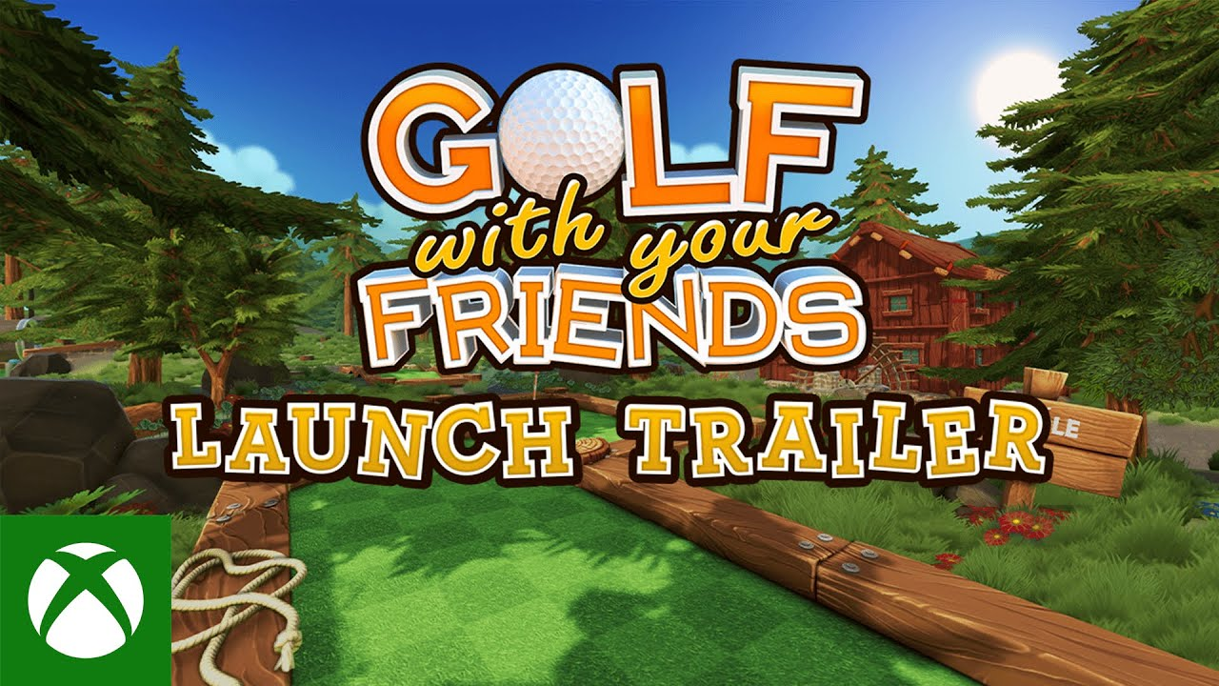
4. Other genres, sub-genres, and hybrid genres
The list above covers core genres, but game design is constantly evolving. New sub-genres emerge, and successful games often blend multiple categories. Here are a few important sub-genres or hybrid genres you might encounter, especially in indie and Unity development:
- Action-Adventure: Games that blend real-time combat and traversal with exploration, puzzles, and narrative progression (for example, God of War, Arashi: Castles of Sin)
- Roguelike / Roguelite: Games with procedural generation, permanent death, and run-based structure (for example, Hades, Slay the Spire)
- Metroidvania: Action platformers with interconnected worlds and ability-gated exploration (for example, Hollow Knight, Ori and the Blind Forest)
- Battle Royale: Multiplayer games where many players compete until one remains (for example, Fortnite, Apex Legends)
- Soulslike: Action RPGs emphasizing precise combat, environmental storytelling, and punishing difficulty (for example, Dark Souls, Elden Ring)
- Idle / Incremental: Games that progress even when you're not playing, focused on optimization and automation (for example, Cookie Clicker, Adventure Capitalist)
- Walking Simulator / Narrative Adventure: Exploration-focused games emphasizing story and atmosphere over challenge (for example, Firewatch, What Remains of Edith Finch)
As an example of this, take a look at the trailer for Slime Rancher 2 below, another game made with Unity.
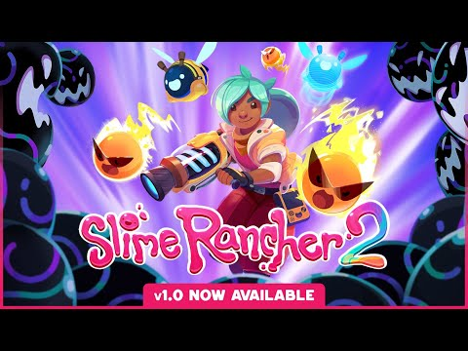
This game blends multiple genres; it plays like a first-person adventure game, but its core loop is a cozy farm life sim where you explore a colorful open world, collect and raise slimes, and manage a ranch economy. It combines elements of simulation/sandbox (building and optimizing your ranch), exploration (discovering new regions and secrets on Rainbow Island), and light shooter-style mechanics (using your Vacpack to aim, vacuum, and launch slimes and resources).
5. Activity: watch and identify
Before classifying your own game in your GDD, practice analyzing an existing one:
1. Explore the Steam pages of one of the games made with Unity below, including the trailers, screenshots, and descriptions
2. Identify the following:
- Primary genre
- 3-5 core player verbs (what actions repeat most often?)
- Any hybrid or sub-genre elements
Links to trailers
- Cuphead
- Kerbal Space Program
- Rust
If you want, post your responses for one of the games in the Q&A section of this lab to share with other learners.
Mark step complete
6. Complete the Art and Visuals section
Now that you’ve been exposed to so many different genres and styles within different genres, you’re ready to fill out the next section of your GDD on Art and Visuals. This section documents the aesthetic identity of your game. External inspiration from other games or art can greatly influence your game's visual style.
By the time you are done with this step, the Art and Visuals section of your GDD should look something like the image below, but with your own unique concept.
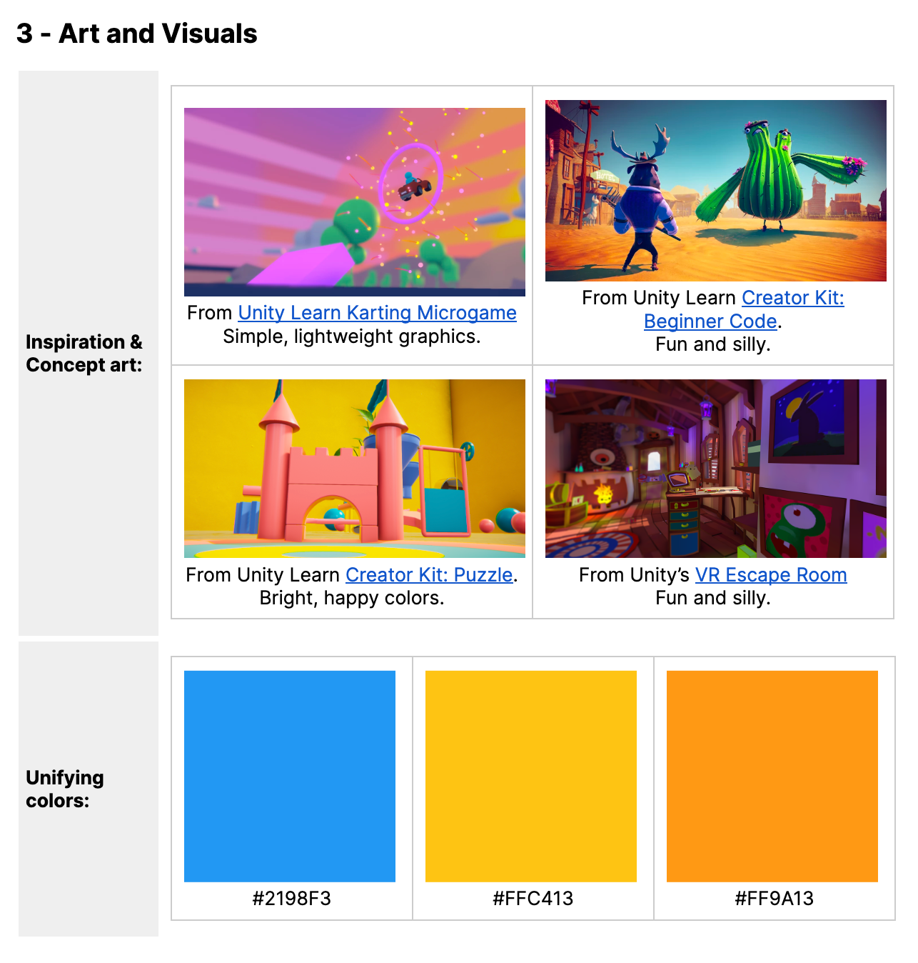
Inspiration and reference images
Include images that inspire your game's visual direction. Concept art is visual artwork created during pre-production to explore and communicate a game's aesthetic vision. Concept art can be extremely beneficial in visualizing your game if you have the skills or resources to create it yourself. Curating images from the internet that inspire your game's aesthetic can be very effective.
Sources can include:
- Screenshots from games with similar aesthetics
- Concept art
- Photos or artwork that capture the mood you're aiming for
- Color palette references
For each image, include the following:
- A brief description of what inspired you about it
- Credit/source link if applicable
To do
Fill out the Inspiration section if you want to include visual references.
Unifying colors
A well-chosen color scheme can make your game visually cohesive and significantly influence its mood and atmosphere. For example, a game like Limbo uses a monochromatic color scheme to create an eerie and mysterious mood. Online tools like color triad generators can be extremely helpful when it comes to creating a suitable color scheme.
Document your color scheme
- Add three color swatch squares with hex codes or RGB values
- Consider using online tools like the Adobe color wheel or Coolors to generate palettes
Example
- Primary colors:
  - Sandy Yellow (#F4D35E)
  - Ocean Blue (#0D3B66)
  - Coral Pink (#EE6352)
To do
Fill out the Unifying Colors section now.
Mark step complete
7. Next steps
In this lab, you explored genres and player actions to think about what players do and expect in a game. You also filled out the Art and Visual section of your GDD.
Next, you'll learn about platforms and monetization, and how those interact with game design and game genres.

